Practice Questions: Cell Structure & Communication
1. All of the following cell components are found in prokaryotic cells EXCEPT
A) DNA
B) ribosomes
C) cell membrane
D) nuclear envelope
E) enzymes
2. The organelle that is a major producer of ATP and is found in both heterotrophs and autotrophs is the
A) chloroplast
B) nucleus
C) ribosome
D) Golgi apparatus
E) mitochondrion
3. If plant cells are immersed in distilled water, the resulting movement of water into the cells is called
A) conduction
B) active transport
C) transpiration
D) osmosis
E) facilitated diffusion
4. Which of the following is the primary role of the lysosome?
A) ATP synthesis
B) Intracellular digestion
C) Lipid transport
D) Carbohydrate storage
E) Protein synthesis
5. Which of the following macromolecules is primarily responsible for the insolubility of cell membranes in water?
A) Starch
B) Cellulose
C) Protein
D) Phospholipid
E) Glycogen
6. The nucleolus functions in the production of
A) Golgi apparatus
B) microtubules
C) mitochondria
D) ribosomes
E) endoplasmic reticulum
7. Simple diffusion and facilitated diffusion are related in that both
A) require protein carriers
B) depend on a concentration gradient
C) occur via contractions of cytoskeletal elements attached to membrane proteins
D) are endergonic processes and thus require the hydrolysis of ATP
E) occur in eukaryotic cells but not in prokaryotic cells

8. Which of the following is correct concerning a spherical cell?
A) As the diameter decreases, the surface area remains the same.
B) As the diameter decreases, the surface area increases.
C) As the diameter decreases, the surface-to-volume ratio increases.
D) As the diameter increases, the volume decreases.

9. Which of the following organelles modifies
and packages for secretion the materials
produced by the ribosomes?
A) The chloroplast
B) The Golgi apparatus
C) The nucleus
D) The nucleolus
E) The mitochondrion

10. A student using a light microscope observes a
cell and correctly decides that it is a plant cell
because
A) ribosomes are visible
B) an endoplasmic reticulum can be seen
C) a cell membrane is present
D) it has a large central vacuole
E) centrioles are present
Questions 11-12 refer to the graph below, which illustrates the percent change in the mass of pieces of
plant tissue placed in solutions of different sucrose molarities.

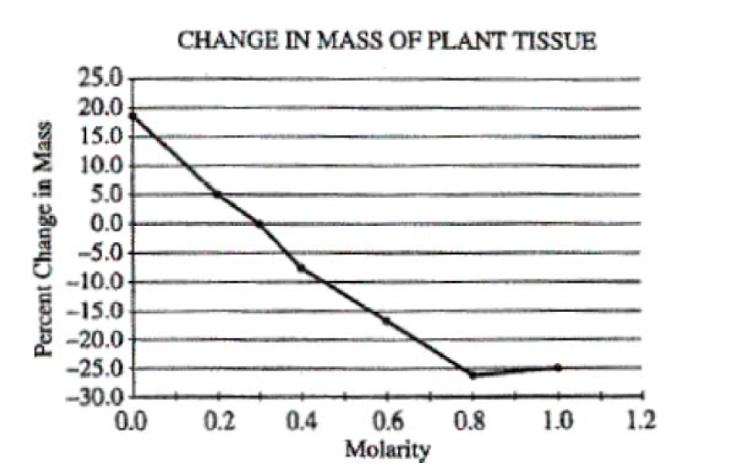
11. Which of the following occurs in the tissue that is placed in 0.6 M sucrose?
(A) The cells become turgid.
(B) The cells burst.
(C) The volume of the vacuoles decreases.
(D) The volume of the cytoplasm increases.

12. The approximate molarity of the solution in which the mass of the plant pieces would not change is
(A) 0.01 M
(B) 0.1 M
(C) 0.3 M
(D) 0.5 M
(E) 0.7 M

